ICEngineSoft Test Report

Report Date : Wed, Dec 14, 2022 , Time : 1:20:42 AM
Organization : Organisation, Operator : Operator
Data File : 13-12 WCO B30.xlsx, Last Modified Date: Tue, Dec 13, 2022,
Config. File : Kirloskar TV1 Engine.xls

Engine Details :

ICEngine set up under test is Kirloskar TV1 having power 5.20 kW @ 1500 rpm which is 1 Cylinder, Four stroke , Constant Speed, Water Cooled, Diesel Engine, with Cylinder Bore 87.50(mm), Stroke Length 110.00(mm), Connecting Rod length 234.00(mm), Compression Ratio 17.50, Swept volume 661.45 (cc)

Combustion Parameters :

Specific Gas Const (kJ/kgK) : 1.00, Air Density (kg/m^3) : 1.17, Adiabatic Index : 1.41, Polytrophic Index : 1.09, Number Of Cycles : 10, Cylinder Pressure Referance : 7, Smoothing 2, TDC Reference :-1

Performance Parameters :

Orifice Diameter (mm) : 20.00, Orifice Coeff. Of Discharge : 0.60, Dynamometer Arm Legnth (mm) : 185, Fuel Pipe dia (mm) : 12.40, Ambient Temp. (Deg C) : 27, Pulses Per revolution : 360, Fuel Type : Diesel, Fuel Density (Kg/m^3) : 851, Calorific Value Of Fuel (kj/kg) : 40596

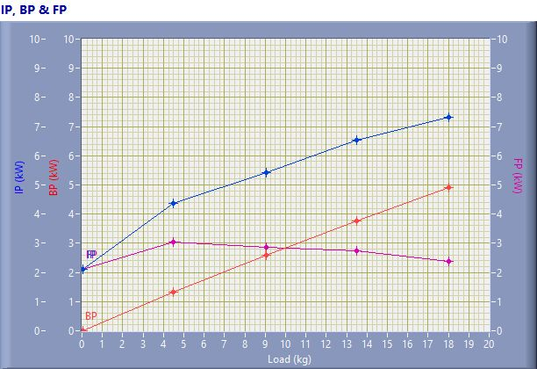

IP, BP & FP

Speed (rpm) | Load (kg) | IP (kW) | BP (kW) | FP (kW)
1556.00 | 0.03 | 2.12 | 0.01 | 2.11
1551.00 | 4.50 | 4.36 | 1.33 | 3.03
1501.00 | 9.06 | 5.43 | 2.58 | 2.85
1471.00 | 13.50 | 6.52 | 3.77 | 2.75
1437.00 | 18.03 | 7.32 | 4.92 | 2.39

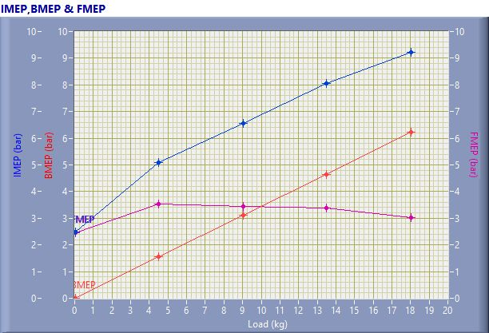

IMEP,BMEP & FMEP

Speed (rpm) | Load (kg) | IMEP (bar) | BMEP (bar) | FMEP (bar)
1556.00 | 0.03 | 2.48 | 0.01 | 2.46
1551.00 | 4.50 | 5.10 | 1.55 | 3.55
1501.00 | 9.06 | 6.57 | 3.12 | 3.44
1471.00 | 13.50 | 8.04 | 4.66 | 3.39
1437.00 | 18.03 | 9.24 | 6.22 | 3.02

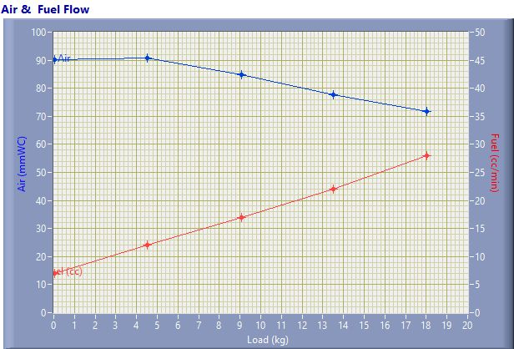

Air & Fuel Flow

Speed (rpm) | Load (kg) | Air (mmWC) | Fuel (cc/min)
1556.00 | 0.03 | 90.25 | 7.00
1551.00 | 4.50 | 90.65 | 12.00
1501.00 | 9.06 | 84.72 | 17.00
1471.00 | 13.50 | 77.77 | 22.00
1437.00 | 18.03 | 71.86 | 28.00

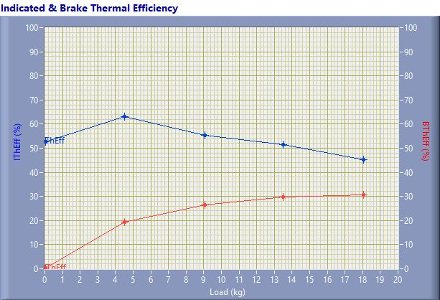

Indicated & Brake Thermal Efficiency

Speed (rpm) | Load (kg) | IThEff (%) | BThEff (%)
1556.00 | 0.03 | 52.67 | 0.23
1551.00 | 4.50 | 63.11 | 19.21
1501.00 | 9.06 | 55.49 | 26.40
1471.00 | 13.50 | 51.48 | 29.80
1437.00 | 18.03 | 45.37 | 30.55

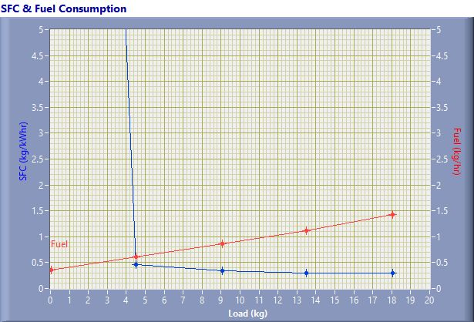

SFC & Fuel Consumption

Speed (rpm) | Load (kg) | SFC (kg/kWh) | Fuel (kg/h)
1556.00 | 0.03 | 37.77 | 0.36
1551.00 | 4.50 | 0.46 | 0.61
1501.00 | 9.06 | 0.34 | 0.87
1471.00 | 13.50 | 0.30 | 1.12
1437.00 | 18.03 | 0.29 | 1.43

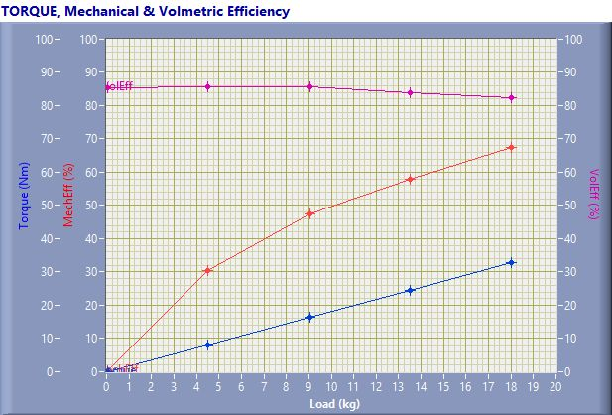

TORQUE, Mechanical & Volmertic Efficiency

Speed (rpm) | Load (Kg) | Torque (Nm) | Mech Eff. (%) | Vol Eff. (%)
1556.00 | 0.03 | 0.06 | 0.45 | 85.35
1551.00 | 4.50 | 8.17 | 30.44 | 85.82
1501.00 | 9.06 | 16.44 | 47.56 | 85.73
1471.00 | 13.50 | 24.51 | 57.88 | 83.81
1437.00 | 18.03 | 32.73 | 67.32 | 82.47

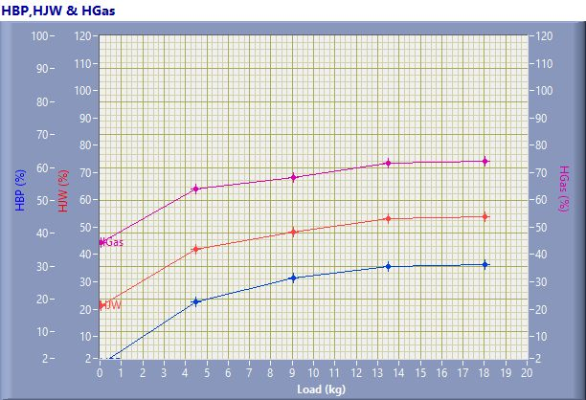

HBP,HJW & HGas

Speed (rpm) | Load (kg) | HBP (%) | HJW (%) | HGas (%) | HRad (%)
1556.00 | 0.03 | 0.23 | 20.99 | 23.15 | 55.63
1551.00 | 4.50 | 19.21 | 22.61 | 22.14 | 36.04
1501.00 | 9.06 | 26.40 | 21.73 | 20.12 | 31.76
1471.00 | 13.50 | 29.80 | 23.29 | 20.35 | 26.56
1437.00 | 18.03 | 30.55 | 23.21 | 20.24 | 26.01

Observation Data

Speed (rpm) | Load (kg) | Comp Ratio | T1 (deg C) | T2 (deg C) | T3 (deg C) | T4 (deg C) | T5 (deg C) | T6 (deg C)
1556 | 0.03 | 17.50 | 38.32 | 43.15 | 38.31 | 37.67 | 124.56 | 101.11
1551 | 4.50 | 17.50 | 38.36 | 47.29 | 38.37 | 39.22 | 185.34 | 139.81
1501 | 9.06 | 17.50 | 38.34 | 50.49 | 38.38 | 41.47 | 235.96 | 176.76
1471 | 13.50 | 17.50 | 38.43 | 55.29 | 38.42 | 44.35 | 309.69 | 225.52
1437 | 18.03 | 17.50 | 38.50 | 59.87 | 38.49 | 47.86 | 394.82 | 279.38

Observation Data

Air (mmWC) | Fuel (cc/min) | WaterFlow Engine (lph) | WaterFlow Cal (lph)
90.25 | 7.00 | 150 | 75
90.65 | 12.00 | 150 | 75
84.72 | 17.00 | 150 | 75
77.77 | 22.00 | 150 | 75
71.86 | 28.00 | 150 | 75

Result Data

Torque (Nm) | BP (kW) | FP (kW) | IP (kW) | BMEP (bar) | IMEP (bar) | BTHE (%) | ITHE (%) | Mech Eff. (%)
0.06 | 0.01 | 2.11 | 2.12 | 0.01 | 2.48 | 0.23 | 52.67 | 0.45
8.17 | 1.33 | 3.03 | 4.36 | 1.55 | 5.10 | 19.21 | 63.11 | 30.44
16.44 | 2.58 | 2.85 | 5.43 | 3.12 | 6.57 | 26.40 | 55.49 | 47.56
24.51 | 3.77 | 2.75 | 6.52 | 4.66 | 8.04 | 29.80 | 51.48 | 57.88
32.73 | 4.92 | 2.39 | 7.32 | 6.22 | 9.24 | 30.55 | 45.37 | 67.32

Result Data

Air Flow (kg/h) | Fuel Flow (kg/h) | SFC (kg/kWh) | Vol Eff. (%) | A/F Ratio | HBP (%) | HJW (%) | HGas (%) | HRad (%)
30.94 | 0.36 | 37.77 | 85.35 | 86.56 | 0.23 | 20.99 | 23.15 | 55.63
31.01 | 0.61 | 0.46 | 85.82 | 50.60 | 19.21 | 22.61 | 22.14 | 36.04
29.98 | 0.87 | 0.34 | 85.73 | 34.53 | 26.40 | 21.73 | 20.12 | 31.76
28.72 | 1.12 | 0.30 | 83.81 | 25.57 | 29.80 | 23.29 | 20.35 | 26.56
27.61 | 1.43 | 0.29 | 82.47 | 19.31 | 30.55 | 23.21 | 20.24 | 26.01

